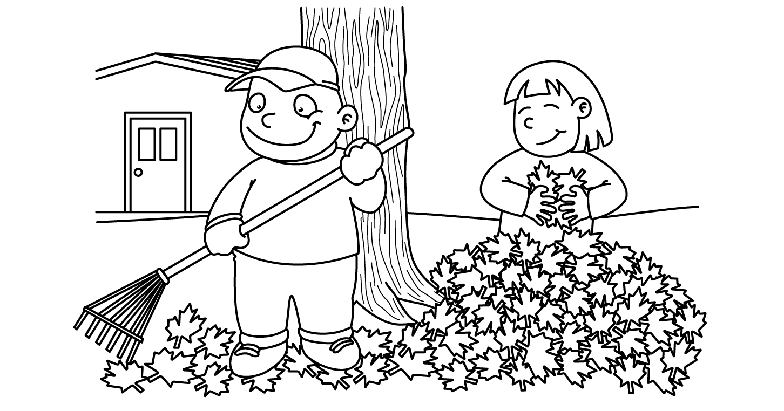

OCTOBER
Sunday | Monday |  | Tuesday | Wednesday |  | Thursday | Friday |  | Saturday
Fall Fun with  Apples  and  Begin Colors |  | 30  Apple Pickin’  Rosh Hashanah | Fire Dill 11am 1  Favorite  Apple  Graph  Yellow |  | 2  Parts  of an  Apples  Yellow | 3  Leaf  Rubbing  Brown |  | 4  Acorn  National Taco Day | 5
6  Fire Prevention | Fire Drill 11:15 7  Flames  (Fire)  Stop, Drop & Roll  Red |  | 8  Fire Truck  Calling 911  Visit from Fireman  Red | 9  National Bring a Teddy Bear to School Day  Yom Kippur |  | 10  Christopher  Columbus  Craft | 11  Sink / Float  Experiment  Science |  | 12
13  Begin  Shapes  &  Continue Colors  Halloween Fun | 14  Columbus Day  School Closed |  | 15  Oscar  the  Grouch  Day  Green | 16  Green  Monster  Green / Circle |  | 17  Witch  Black / Triangle | 18  Black  Cast  Chocolate Cupcake Day |  | 19
20  Our  Five  Senses | 21  Homemade  Pumpkin  Play-Doh  Smell |  | 22  Baking  Apple  Pops  Taste | 23  Popcorn  Ghost  Hearing |  | 24  Mask  Sight | 25  Shaving  Cream Experiment  Touch |  | 26
27  More  Halloween  Fun  Diwali | 28  Halloween  Treat  Bag  Rectangle |  | 29  Pumpkin Carving  Orange  Circle / Rectangle | 30  Candy  Corn  Day  Orange / Triangle |  | 31  Halloween  Party | 1  Show  -n-  Tell  Fall Object

