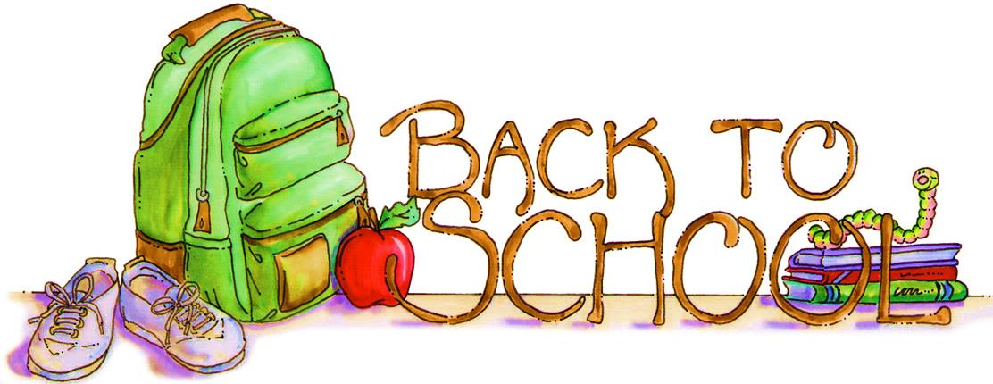

SEPTEMBER
Sunday | Monday | Tuesday | Wednesday | Thursday | Friday | Saturday
1  Welcome | 2  Happy  Labor  Day ! | 3 | 4  Welcome  to  School  First Day of School | 5  Making Friends  A Magical Year  First Day of School  For Some Children | 6  Grandparent  Project | 7
8  Getting  Acclimated  Grandparents Day | 9  School  is  Fun | 10  Rules  and  Routines | 11  Exploring  Our  Centers  at School | 12  Play  and  Put Away | 13  I  Love  School | 14
15  All About Me | 16  All  About  Me | 17  I  Like  Me | 18  My  Body | 19  Healthy  Me | 20  I’m  Special | 21  International Day of Peace
22  My Family  and  Home | 23  Fall  Is  Here  First Day of Fall | 24  Show  -n-  Tell  Family Photo | 25  My  Family | 26  All  Families  are  Special | 27  My  House | 28
29 | 30  Rosh  Hashanah  Rosh Hashanah

