Ms. Christine
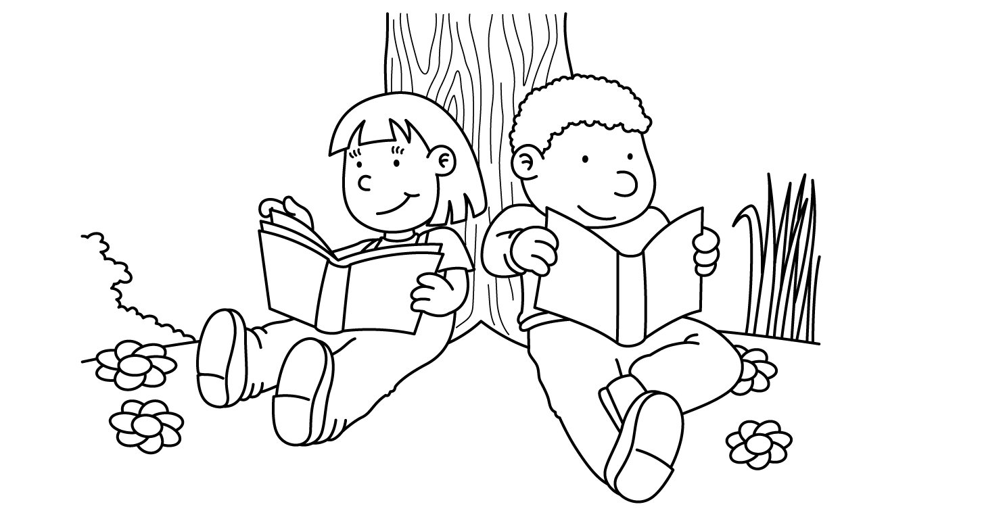

JUNE
Sunday | Monday | Tuesday | Wednesday | Thursday | Friday | Saturday
 |  |  |  |  |  | 1
2 | 3  Father’s Day Surprise | 4  Father’s Day Surprise | 5  Family Fun Day  at D’Onofrio Park  10:00 – 2:00  School Closed | D-Day 6  Pajama Day | 7  National  Donut  Day | 8  Flag Day
9 | 10  Animal  Party | 11  Review  and  Testing | 12  Review  and  Testing | 13  Show  -n-  Tell | 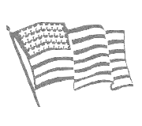  14  Flag Day | 15
16  Happy  Father’s Day | 17  End of Year  Special Books | 18  Chicka Chicka  Boom Boom  Party | 19  Picnic  in the  Park  First Day of Summer | 20  Halloween  in  June  (Wear a Costume)  Report Cards | 21  First Day  Of  Summer  Peaches & Cream Day  Report Cards | 22
23  30 | 24  Ice Cream  Party | 25  Last Day  Of School  Fun | 26  Graduation  Day! | 27 | 28 | 29

