Ms. Niki
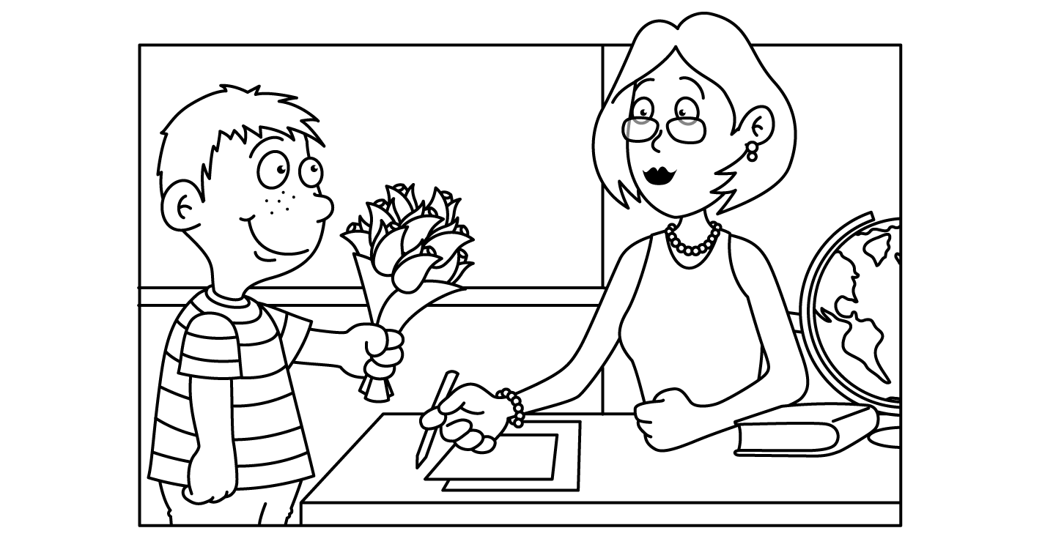

MAY
Sunday | Monday | Tuesday | Wednesday | Thursday | Friday | Saturday
Dinosaur  Week | Ff 29  Fossil | Ff 30  Fukuiraptor  National Bugs  Bunny Day | 1  T-Rex | 2  Stegosaurus | 3  Brontosaurus | 4  Cinco de Mayo
5  Mother’s Day Craft  Cinco de Mayo | Yy 6  Yellow Yarn  Yo-Yo | Yy 7  Yes Day !  Teacher Appreciation Day | Xx 8  Hugs  Mother’s Day Craft | Xx 9  Kisses  Mother’s Day Craft | 10  Science Friday | 11
12  Space Week  Happy  Mother’s  Day | 13  Earth | 14  Stars  Moon  Sun | 15  Rocket Ship  National Chocolate Chip Day | 16  Astronaut | 17  Solar  System | 18  National Pizza Party Day
19  Insect  Week | 20  Ladybug | 21  Caterpillar | 22  Ant  Vanilla Pudding Day | Bb 23  Bee | Bb 24  Butterfly  National Brother Day | 25
26  Circus  Week | 27  Memorial Day  School Closed | 28  School Closed | 29  Clown | Jj 30  Juggler  National Hole in My Bucket Day | 31  Show  -n-  Tell

