Ms. Christine
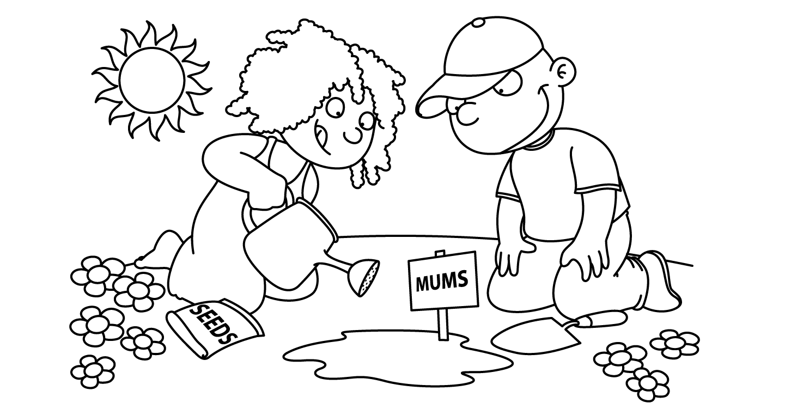

APRIL
Sunday | Monday | Tuesday | Wednesday | Thursday | Friday | Saturday
Zoo  Week | Zz 1  Zookeeper  April Fool’s Day | Zz 2  Zebra  International  Children’s Book Day  and  National PB&J Day | 3  Elephant | Qq 4  Quail | Qq 5  Picture Day  Child of the Week  GEORGE | 6  Last Day of Passover
7  Easter  and  Passover | Ee 8  Easter  Basket | Ee 9  Egg | 10  Bunny  National Sibling Day | 11  Spring  Wreath  Egg Hunt | 12  Passover  Craft  Child of the Week  JORDAN | 13
14 | 15  Tax Day | 16 | 17  Animal Cracker Day | 18  National High Five Day | 19 | 20  First Day of Passover
21  Planting  Happy Easter | 22  School  is  Closed  Earth Day | 23  Parts  of a  Flower  National Picnic Day | 24  Seed,  Sun  and  Water | 25  Parts  of a  Tree  Take Your Child to Work Day | Fire Drill 26  Arbor Day  We Planted Today  Pretzel Day  Child of the Week  PENELOPE | 27  Passover Ends
28  Dinosaur  Week | Ff 29  Fossil | Ff 30  Fukuiraptor  Bugs Bunny Day | 1  T-Rex | 2  Stegosaurus | 3  Brontosaurus  Child of the Week  AARON

