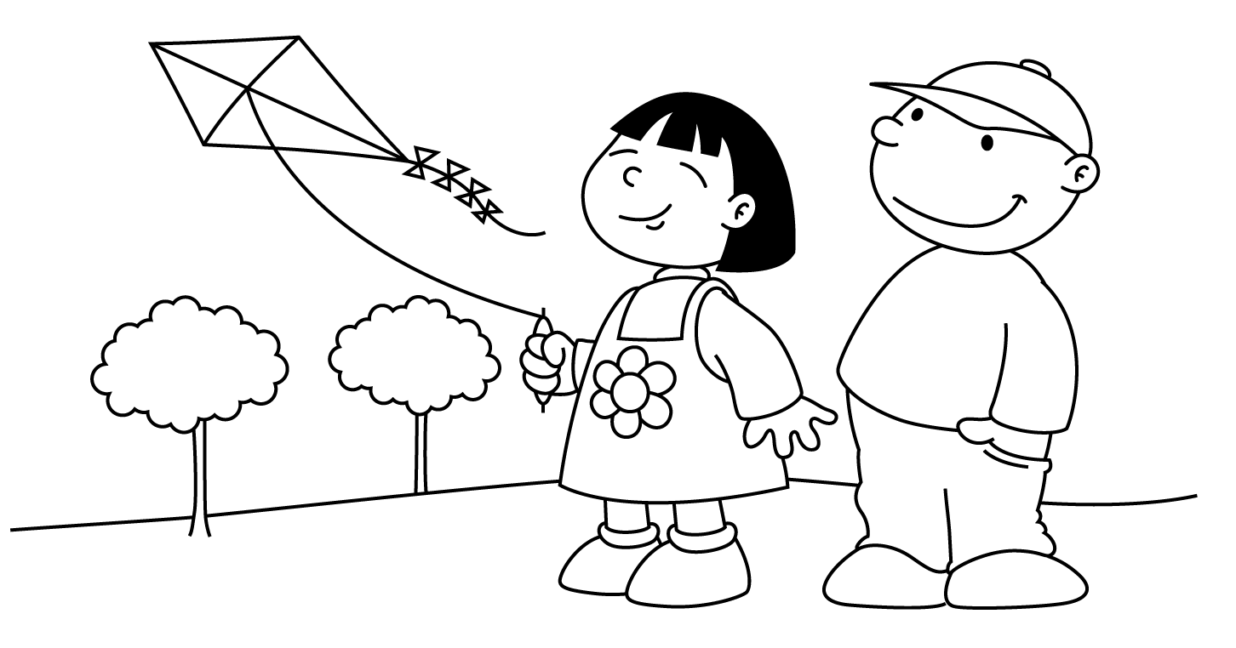

MARCH
Sunday |  | Monday | Tuesday | Wednesday | Thursday | Friday | Saturday
 |  |  |  |  |  | 1  Toothpaste  Child of the Week  Antonia |  | 2  Dr. Seuss’ Birthday  Read Across America Day
3  Dr. Seuss Week  Rhyming | Dd 4  Cat  In the  Hat  Wear Stripes |  | Dd 5  One  Fish  Two  Fish  Mardi Gras | 6  Wacky  Wednesday  Dress A Little Wacky | 7  Green Eggs  and Ham | 8  Lorax  Child of the Week  EMERY |  | 9
10  St. Patrick’s Day  Fun  Daylight Savings Time  Set Clocks Ahead |  | 11  Leprechaun | 12  Show  -n-  Tell | Gg 13  Pot O’ Gold | Gg 14  Green  Shamrock | 15  Visit from Lucky  Wear Green Day  Child of the Week  GIULIANA |  | 16
17  Happy  St. Patrick’s  Day  Spring is Coming |  | Rr 18  Rain | Rr 19  Rainbow | 20  First Day  of  Spring | Nn 21  Nest | Nn 22  Springtime  Noises  Child of the Week  MATTIAS |  | 23
24  31 |  | 25  Weather  Changes | Ee 26  Wind  Windmill | 27  Kite | Uu 28  Umbrella | Uu 29  Unicorn  Child of the Week  CAMILLA |  | 30

