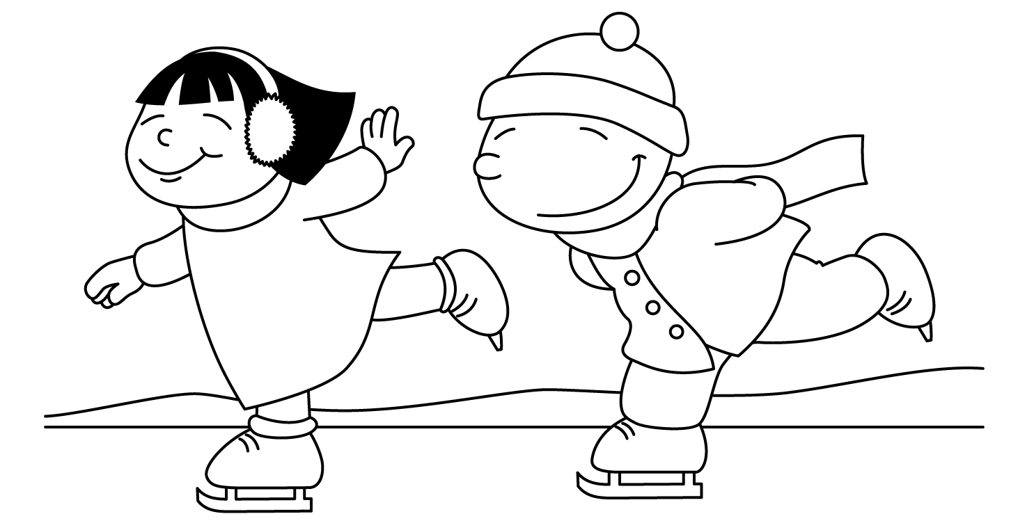
Ms. Niki

JANUARY
Sunday | Monday | Tuesday | Wednesday | Thursday | Friday | Saturday
 | 1 | 1  Happy  New Year!  School is Closed | 2  School is Closed | 3  Welcome Back  Ringing in 2019 | 4  Show  -n-  Tell  Favorite  Holiday Gift | 5
6  Begin Letters | Ss 7  Snowflakes | Ss 8  Sled | Ww 9  Winter  Wonderland | Ww 10  Warm  Watercolor  Mittens | 11  Pajama Day | 12
13  Winter | Mm 14  Mittens | Mm 15  Magical  Snowman | Ii 16  Igloo | Ii 17  National Kid  Iventor Day | 18  Martin Luther King, Jr Project | 19
20  Arctic Animals | 21  Martin Luther King, Jr Day  School is Closed | Pp 22  Polar Bear  National Pie Day | Pp 23  Penguin | Oo 24  Owl | Oo 25  Opposite Day | 26
27 | 28  Review  National Kazoo Day | 29  Puzzle Day  Report Cards | Bb 30  Boots  Left/Right | Bb 31  yaD sdrawkcaB  (Backwards Day)  Report Cards | 1  Silly Hat Day  Report Cards

