Ms. Niki

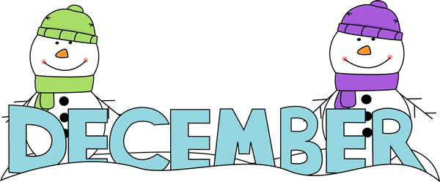
Sunday | Monday | Tuesday | Wednesday | Thursday | Friday |  | Saturday
 |  |  |  |  |  |  | 1
2  Hanukkah Begins | #7 3  Countdown Calendar  First Day of Hanukkah | #7 4  Stockings  National Sock Day | #8 5  Menorah | #8 6  Dreidel  Fire Drill 2:45 | Review #7 & #8 7  Show -n- Tell  Something with Your Favorite Number  Pearl Harbor  Remembrance Day |  | 8
9 | #9 10  Holiday  Gift and Card | #9 11  Holiday  Gift and Card | #10 12  Elf  on the  Shelf | #10 13  Christmas  Tree  Last Day of Hanukkah  National Hot Cocoa Day | Review #9 & #10 14  Wreath |  | 15  National Wreath Day
16 | 17  Santa Claus | 18  Reindeer | 19  Kwanzaa | 20  Baking  Party  Gingerbread Man | 21  Holiday  Party  First Day of Winter |  | 22
23  30 | 24 Christmas Eve  New Year’s Eve 31 | 25  Christmas | 26  First Day of Kwanzaa | 27 |  | 28 |  | 29

