Ms. Christine

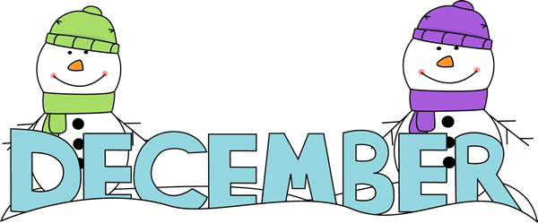
Sunday | Monday | Tuesday | Wednesday | Thursday | Friday |  | Saturday
 |  |  |  |  |  |  | 1
2  Hanukkah Begins | #7 3  Calendar  Countdown  First Day of Hanukkah | #7 4  Stockings  National Sock Day | #8 5  Menorah | #8 6  Dreidel  Fire Drill 2:45 | Review #7 & #8 7  Bulletin  Board  Decoration  Pearl Harbor  Remembrance Day |  | 8
9 | #9 10  Holiday  Gift and Card  Last Day of Hanukkah | #9 11  Holiday  Gift and Card  Noodle Ring Soup Day | #10 12  Gingerbread  House  Day | #10 13  Cocoa  Day  National Hot Cocoa Day | Review #9 & #10 14  Wreath |  | 15  National Wreath Day
16 | 17  Tree | 18  Kwanzaa | 19  Reindeer | 20  Bake  and  Decorate  Cookies | 21  Holiday  Party  First Day of Winter |  | 22
23  30 | 24 Christmas Eve  New Year’s Eve 31 | 25  Christmas | 26  First Day of Kwanzaa | 27 |  | 28 |  | 29

