Ms. Christine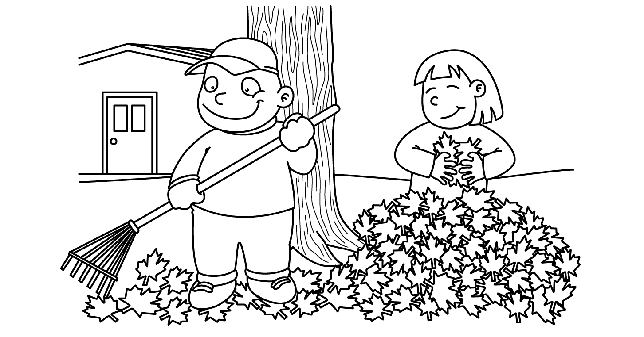

OCTOBER
Sunday | Monday | Tuesday | Wednesday | Thursday | Friday | Saturday
Fall Fun with  Apples | 1  Apple Pickin’ | Fire Dill 11am 2  Parts  of an  Apple  Meet My Teacher Night | 3  Baking  with  Apples | 4  Sink & Float  Science | 5  Columbus Day  Project  Do Something Nice Day | 6
7  Fire Prevention  Week | 8  Columbus Day  School Closed | 9  Look,  Listen  Learn  Stop, Drop & Roll | 10  Calling  911  National Bring a Teddy Bear to School Day | 11  Fireman | 12  Flames  Science | 13
14  Begin  Shapes  &  Colors | 15  Fall  Wreath  Circle | 16  Slice  of  Pumpkin Pie  Circle | 17  Spookley  the  Pumpkin  Square | 18  Haunted House  Square  Black | 19  I SPY  Shapes Everywhere  Review Circle & Square | 20
21  Halloween  Fun | 22  Frankenstein  Rectangle | 23  Treat  Bags  Rectangle | 24  Witch’s  Hat  Triangle | 25  Candy  Corn  Triangle | 26  National  Pumpkin  Day  Review Shapes | 27
28  Our  Five  Senses | 29  Homemade  Play-Doh  Smell | 30  Pumpkin Carving  Touch | 31  Happy  Halloween  Halloween Party | 1  Show  -n-  Tell  Sight | 2  Baking  Taste | 3

