Ms. Niki
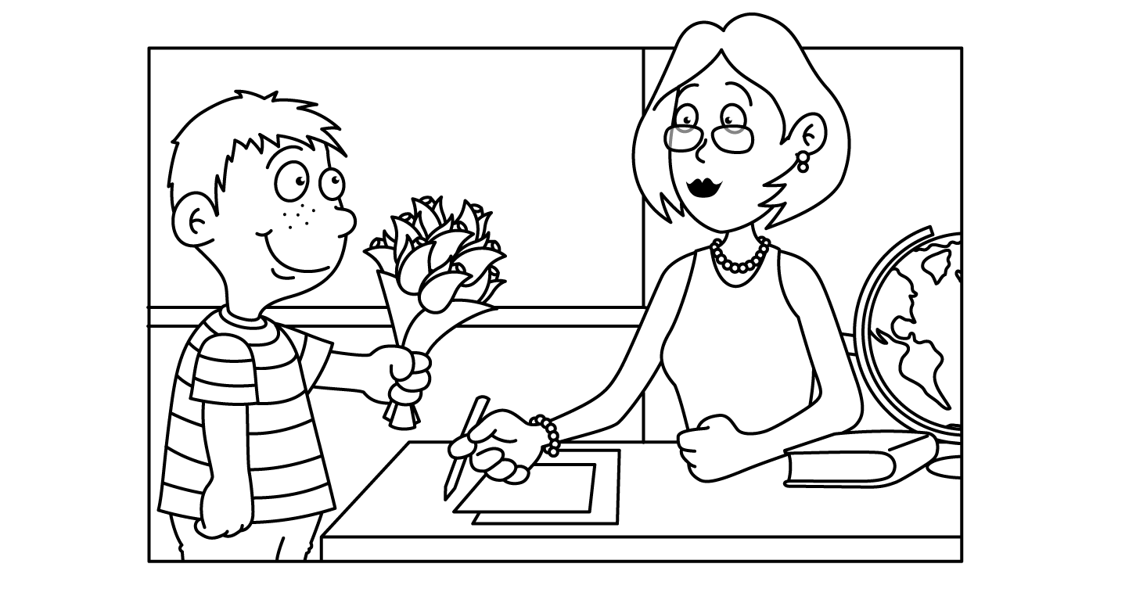

MAY
Sunday | Monday | Tuesday | Wednesday | Thursday | Friday | Saturday
Insect  Week | 30  Caterpillar | 1  Bee | 2  Butterfly  Dance | 3  Ant | 4  Firefly | 5  Cinco de Mayo
6  Mother’s Day Craft | Oo 7  “Hugs” | Oo 8  Show  -n-  Tell | Xx 9  “Kisses”  Mother’s Day Gift | Xx 10  Mother’s  Day  Gift / Card | 11  Yoga | 12
13  Space Week  Happy  Mother’s  Day | 14  Sun | 15  Moon  National Chocolate Chip Day | 16  Stars | 17  Solar  System | 18  Planets | 19
20  Dinosaur  Week | 21  TyrannosaurusRex | 22  Fossils  National  Vanilla Pudding Day | 23  Stegosaurus | 24  Triceratops | 25  School Closed | 26
27  Circus  Week | 28  Memorial Day  School Closed | 29  Elephant | 30  National Hole in My Bucket Day | Cc 31  Clown | Cc 1  Circus

