Ms. Christine
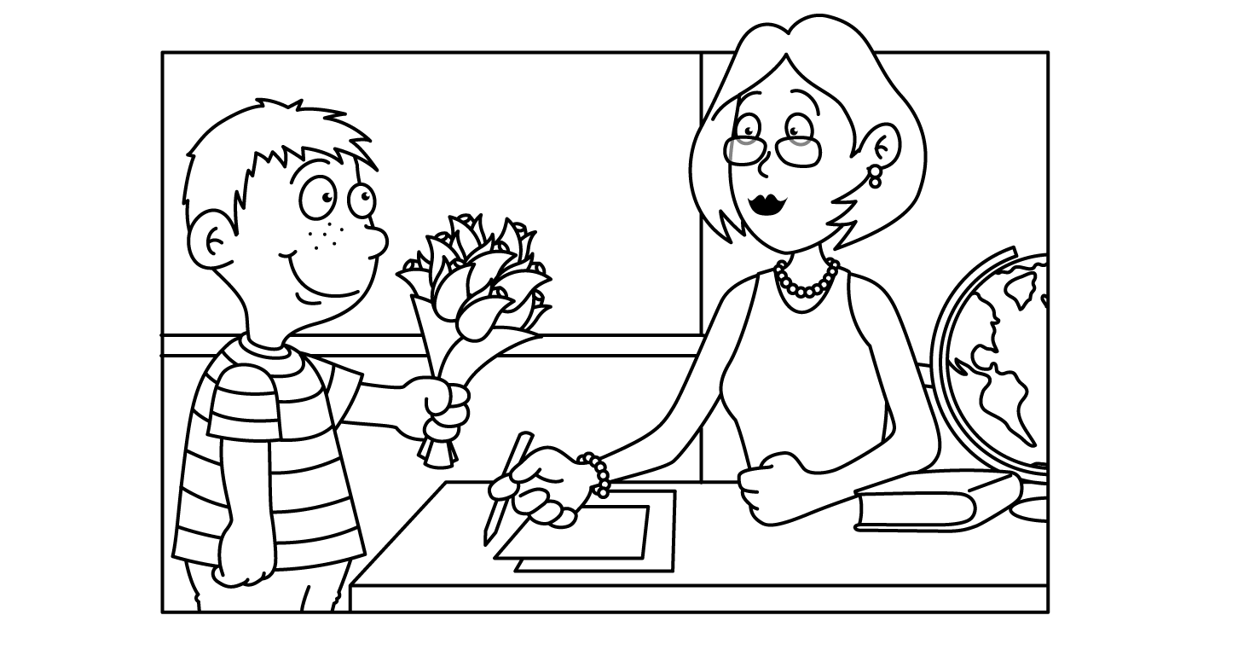

MAY
Sunday | Monday | Tuesday | Wednesday | Thursday | Friday | Saturday
Insect  Week | 30  Caterpillar | 1  Bee | 2  Ant | 3  Firefly | 4  Butterfly  Child of the Week  HARRY | 5  Cinco de Mayo
6  Mother’s Day Craft | Oo 7  Oh, What a Beautiful Day | Oo 8  Show  -n-  Tell | Xx 9  Hugs  Mother’s Day Craft | Xx 10  Kisses  Mother’s Day Craft | 11  Yoga  Child of the Week  CHASE | 12
13  Space Week  Happy  Mother’s  Day | 14  Sun | 15  Moon  National Chocolate Chip Day | 16  Planets | 17  Stars | 18  Solar  System  Child of the Week  BORIS | 19
20  Dinosaur  Week | 21  TyrannosaurusRex | 22  Fossils  Vanilla Pudding Day | 23  Stegosaurus | 24  Triceratops | 25  School Closed | 26
27  Circus  Week | 28  Memorial Day  School Closed | 29  Elephant | 30  National Hole in My Bucket Day | Cc 31  Clown | Cc 1  Circus

