Ms. Niki
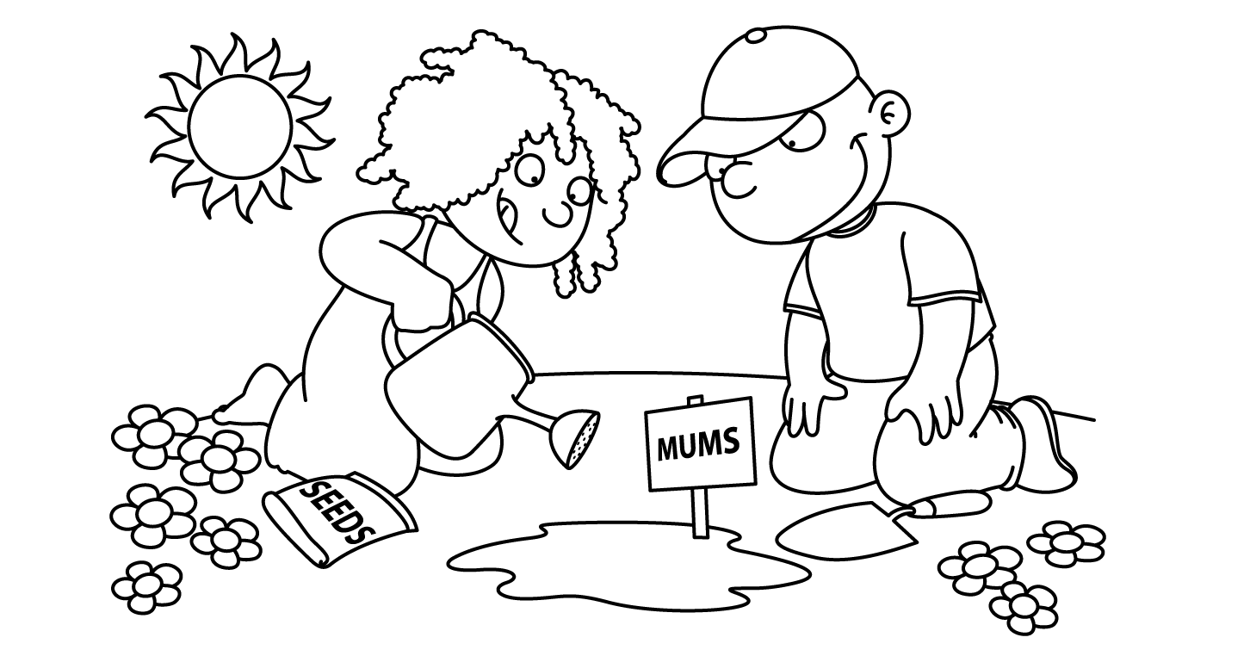

APRIL
Sunday | Monday | Tuesday | Wednesday | Thursday | Friday | Saturday
1  Happy  Easter  April Fool’s Day | 2  International  Children’s Book Day  and  National PB&J Day  School Closed | 3  School Closed | 4  School Closed | 5  School Closed | 6  School Closed | 7  Last Day of Passover
8  Farm  Week | 9  Barn | 10  Rooster | 11  Horse | 12  Farmer  Egg Hunt | 13  PICTURE DAY | 14
15  Zoo  Week | 16  Pajama  Day | Aa 17  Alligator | Aa 18  Animals  in the  Zoo  Animal Cracker Day | Zz 19  Zebra  National High Five Day | Zz 20  Zoo | 21
22  Taking Care of Our Planet  and  Planting  Earth Day | Rr 23  Reuse  National Picnic Day | Rr 24  Recycle | 25  Parts  of a  Flower | 26  Seeds  Take Your Child to Work Day | 27  Planting  Arbor Day | 28
29  Insect  Week | 30  Caterpillar

