Ms. Rose
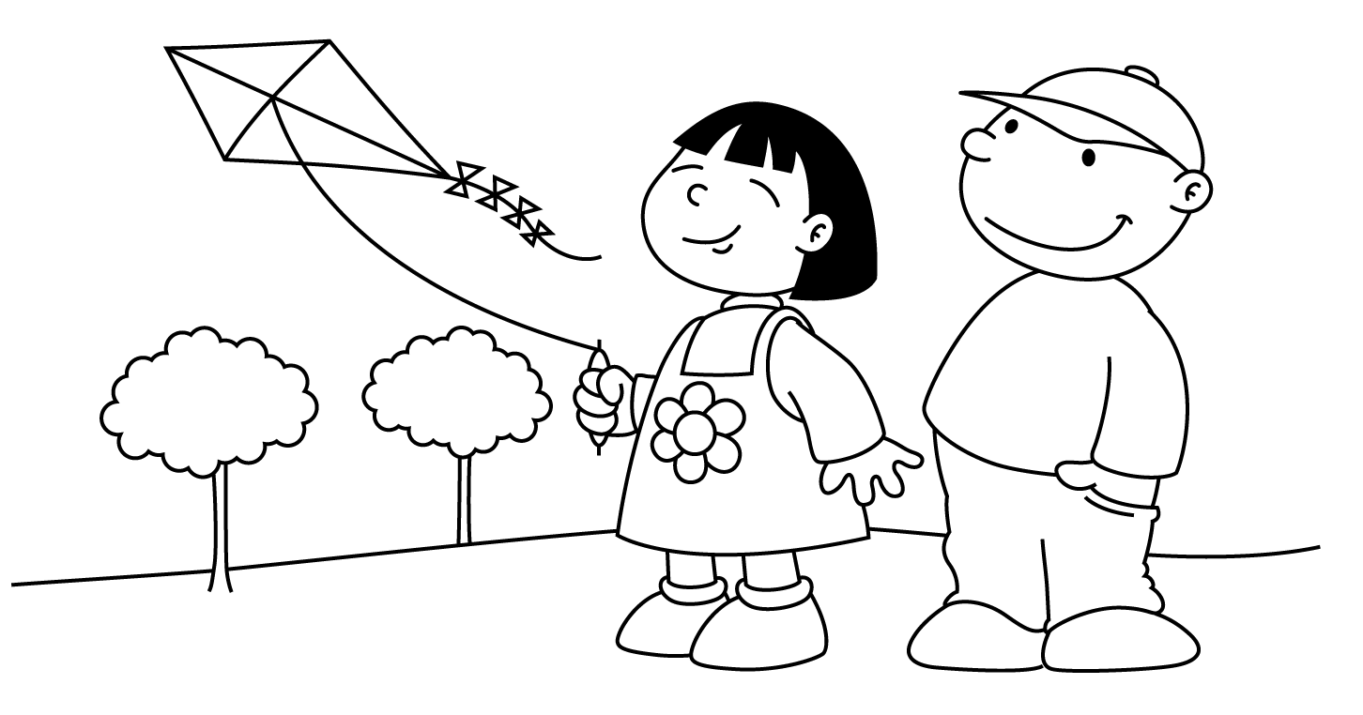

MARCH
Sunday | Monday | Tuesday | Wednesday | Thursday | Friday | Saturday
 |  |  |  | 1  Before / After | 2  In Front / Behind  Dr. Seuss’ Birthday  Read Across America Day |  | 3
4  Dr. Seuss Week  Rhyming | Dd 5  Cat  In the  Hat | Dd 6  Fox  In Socks  Wear Silly Socks Day | 7  One  Fish  Two  Fish | 8  Thing 1  and  Thing 2 | 9  Green Eggs  and Ham |  | 10
11  St. Patrick’s Day  Fun  Daylight Savings Time  Set Clocks Ahead | 12  Pot O’ Gold | 13  Show  -n-  Tell  Something Green | 14  Shamrock  Collage | 15  Leprechaun | 16  Visit from Lucky  Green Experiment  Wear Green Day |  | 17  Happy  St. Patrick’s  Day
18  Spring | Kk 19  Koala  Bear | Kk 20  Kite  First Day of Spring | Uu 21  Umbrella | Uu 22  Up, Up  and Away  Wind | 23  Rain  and  Rainbows |  | 24
25  Easter  Projects | Ee 26  Easter  Bunny | Ee 27  Easter  Basket | Ee 28  Easter  Egg | 29  Passover  Project | 30  Spring Break Begins  School is Closed |  | 31  Passover

