Ms. Christine
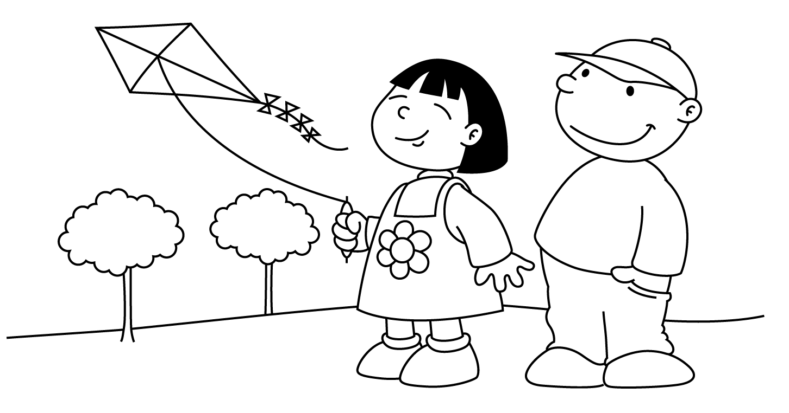

MARCH
Sunday | Monday | Tuesday | Wednesday | Thursday | Friday | Saturday
 |  |  |  | 1  National  Piggy Day | 2  Oh the Places  I’ll Go  Dr. Seuss’ Birthday  Read Across America Day  Child of the Week  MARINA |  | 3
4  Dr. Seuss Week  Rhyming | Dd 5  Cat  In the  Hat | Dd 6  Fox  In Socks  Wear Silly Socks Day | 7  One  Fish  Two  Fish | 8  Lorax | 9  Green Eggs  and Ham  Child of the Week  ADAM |  | 10
11  St. Patrick’s Day  Fun  Daylight Savings Time  Set Clocks Ahead | 12  Shamrock | 13  Show  -n-  Tell  Something Green | 14  Pot O’ Gold | 15  Leprechaun | 16  Visit from Lucky  Wear Green Day  Child of the Week  KADEN |  | 17  Happy  St. Patrick’s  Day
18  Spring | Kk 19  Koala  Bear | Kk 20  Kite  First Day of Spring | Uu 21  Up, Up  and Away | Uu 22  Unicorn | 23  Rainbow  Child of the Week  EMILIE |  | 24
25  Easter  Projects | Ee 26  Easter  Bunny | Ee 27  Easter  Egg | 28  Basket | 29  Passover  Project  Child of the Week  MATTHEW | 30  Spring Break Begins  School is Closed |  | 31  Passover

