Ms. Rose
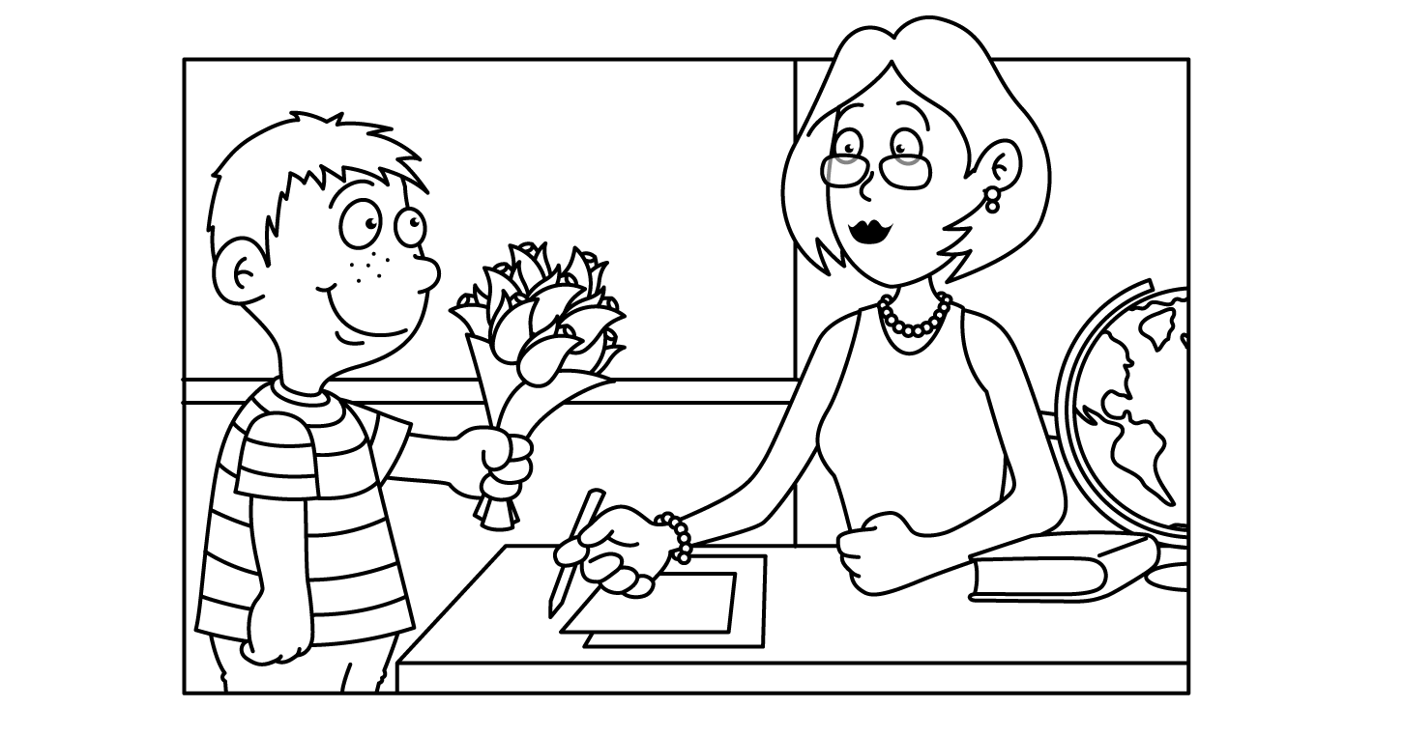

MAY
Sunday | Monday | Tuesday | Wednesday | Thursday | Friday | Saturday
Insects | Cc 1  Caterpillar | Cc 2  Cricket | 3  Bumble Bee  Dance | Aa 4  Ant | Aa 5  Cinco de Mayo  Child of the Week  MICKEY | 6
7  Mother’s Day Craft | Xx 8  Mother’s Day Crafts & Card  Hugs and Kisses | Xx 9  Mother’s Day Crafts & Card  Hugs and Kisses | Oo 10  Mother’s Day Craft & Card  Hugs and Kisses | Oo 11  Show  -n-  Tell | 12  Butterfly | 13
14  Farm  Happy Mother’s Day | 15  Cow | 16  Horse | 17  Pig | 18  Duck | 19  Rooster  National Pizza Day | 20
21  Space | 22  Astronaut | 23  Rocket Ship | Jj 24  Jupiter | 25  Sun | 26  Moon  Child of the Week  RYAN | 27
28  Dinosaur | 29  Memorial Day  School Closed | 30  School Closed | 31  T-Rex

