Ms. Niki
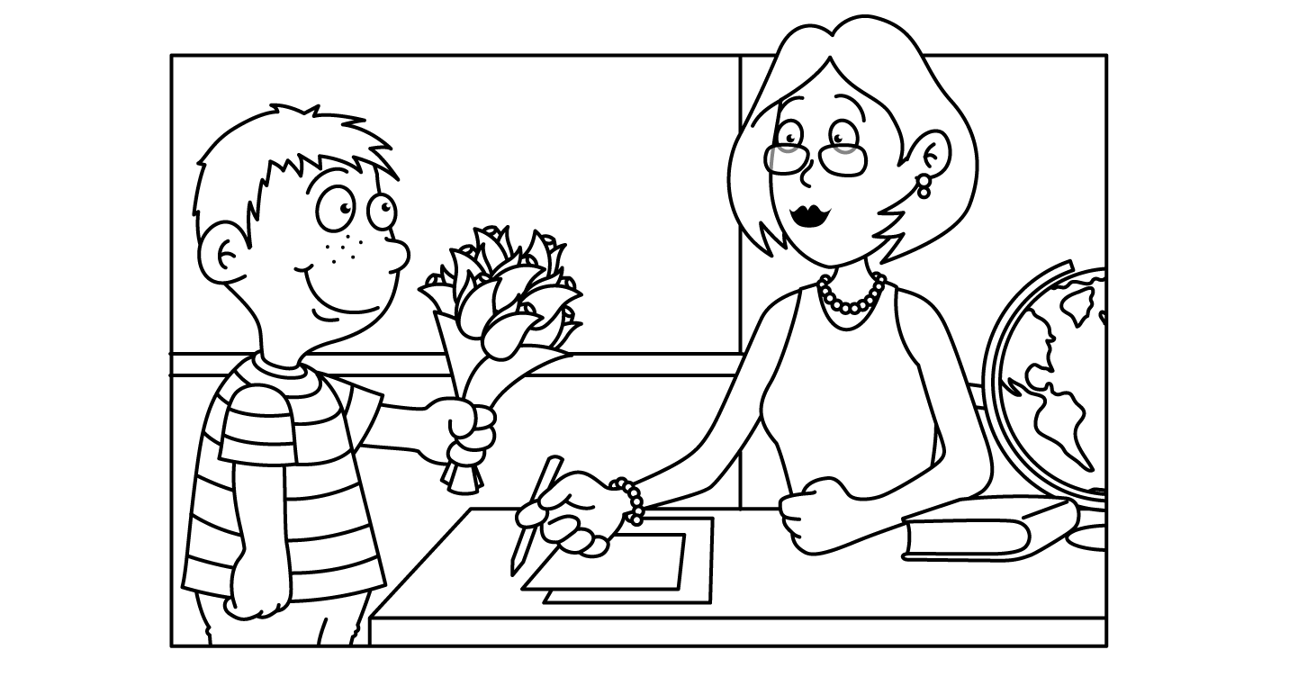

MAY
Sunday | Monday | Tuesday | Wednesday | Thursday | Friday | Saturday
Insects | Cc 1  Caterpillar | Cc 2  Cricket | 3  Bumble Bee | Aa 4  Ant | Aa 5  Cinco de Mayo | 6
7  Mother’s Day Craft | Xx 8  Mother’s Day Crafts & Card  Hugs | Oo 9  Mother’s Day Crafts & Card  Kisses | Oo 10  Mother’s Day Craft & Card  Kisses | Xx 11  Show  -n-  Tell | Oo 12  Mother’s Day Crafts & Card  Kisses | 13
14  Farm  Happy Mother’s Day | 15  Cow | 16  Pig | 17  Horse | 18  Duck | 19  Rooster  National Pizza Day | 20
21  Space | 22  Planets | 23  Astronaut | Jj 24  Jupiter | 25  Sun and Moon | 26  Rocket Ship | 27
28  Dinosaur | 29  Memorial Day  School Closed | 30  School Closed | 31  T-Rex

