Ms. Rose
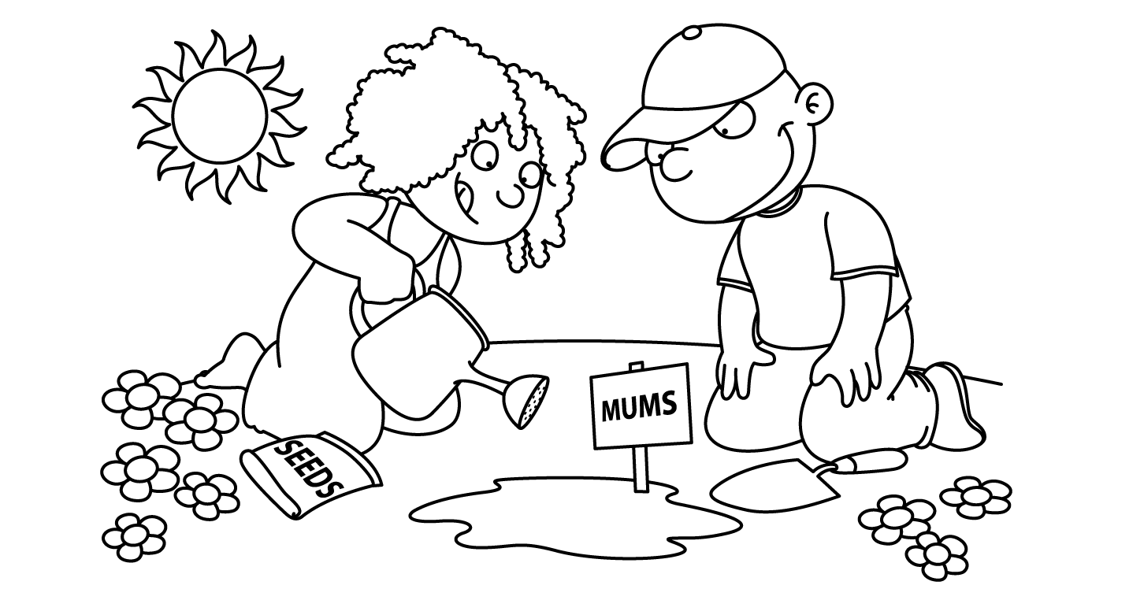

APRIL
Sunday | Monday | Tuesday | Wednesday | Thursday | Friday | Saturday
1
Happy
April Fool’s Day

April Fool’s Day
2  International  Children”s Book Day  National PB&J Day | 3  Bunny  Basket | 4  Passover  Craft | Ee 5  Eggs  Dance | Ee 6  Egg Hunt | 7  Picture  Day | 8
9 | 10  School Closed | 11  First Day of Passover  School Closed | 12  School Closed | 13  School Closed | 14  School Closed | 15
16  Happy Easter | 17  School Closed | 18  Parts  of a  Plant  Last Day of Passover  Tax Day | 19  Seed | 20  Sun  and  Soil | 21  Parts  of a  Tree | 22  Earth Day
30  Zoo | Zz 31  Zoo  Keeper | Zz 25  Zebra | 26  Giraffe | 27  Peacock  Take Your Child to Work Day | 28  Show  and  Tell  Zoo Animal  Arbor Day | 29

