Ms. Niki
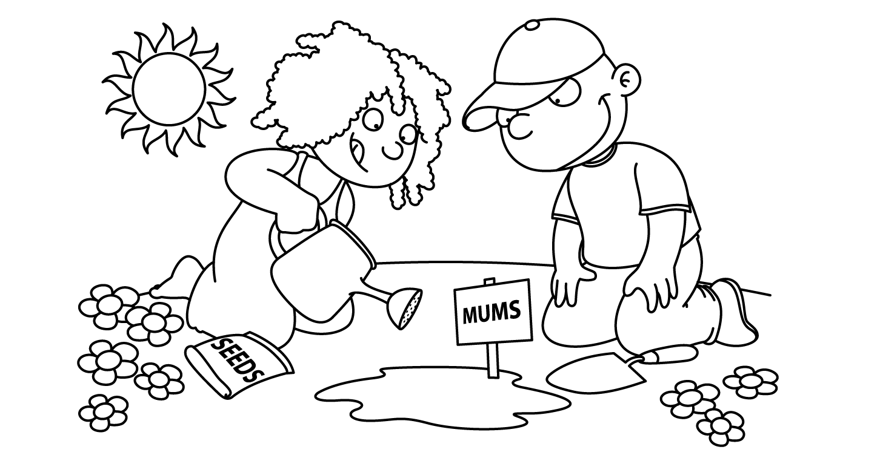

APRIL
Sunday | Monday | Tuesday | Wednesday | Thursday | Friday | Saturday
1
Happy
April Fool’s Day

April Fool’s Day
2  International  Children’s Book Day  National PB&J Day | 3  Bunny | 4  Passover  Craft | Ee 5  Easter  Eggs | Ee 6  Egg Hunt | 7  Picture  Day | 8
9 | 10  School Closed | 11  First Day of Passover  School Closed | 12  School Closed | 13  School Closed | 14  School Closed | 15
16  Happy Easter | 17  School Closed | 18  Parts  of a  Plant  Last Day of Passover  Tax Day | 19  Seeds  Dance | 20  Sun  and  Soil | 21  Parts  of a  Tree | 22  Earth Day
30  Zoo | Zz 31  Zebra | Zz 25  Zoo  Keeper | 26  Elephant | 27  Giraffe  Take Your Child to Work Day | 28  Show  and  Tell  Zoo Animal  Arbor Day | 29

