Ms. Christine
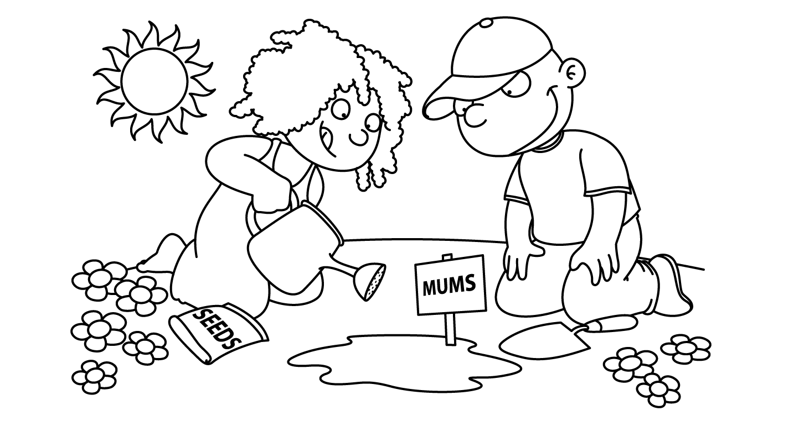

APRIL
Sunday | Monday | Tuesday | Wednesday | Thursday | Friday | Saturday
1
Happy
April Fool’s
Day

April Fool’s Day
2  International  Children’s Book Day  National PB&J Day | 3  Bunny | 4  Basket | Ee 5  Easter Eggs | Ee 6  Matzah Man  Egg Hunt | 7  PICTURE DAY  Child of the Week  MADILYNN | 8
9 | 10  School Closed | 11  First Day of Passover  School Closed | 12  School Closed | 13  School Closed | 14  School Closed | 15
16  Happy Easter | 17  School Closed | Tt 18  Parts  of a  Plant  Last Day of Passover  Tax Day | Tt 19  Seeds  Dance | 20  Sun  and  Soil | 21  Parts  of a  Tree  Child of the Week  SAANVI | 22  Earth Day
30  Zoo | Zz 31  Zoo | Zz 25  Zebra | 26  Panda Bear | 27  Peacock  Take Your Child to Work Day | Arbor Day 28  Show  and  Tell  Zoo Animal  Child of the Week  SAMMY | 29

