Ms. Rose
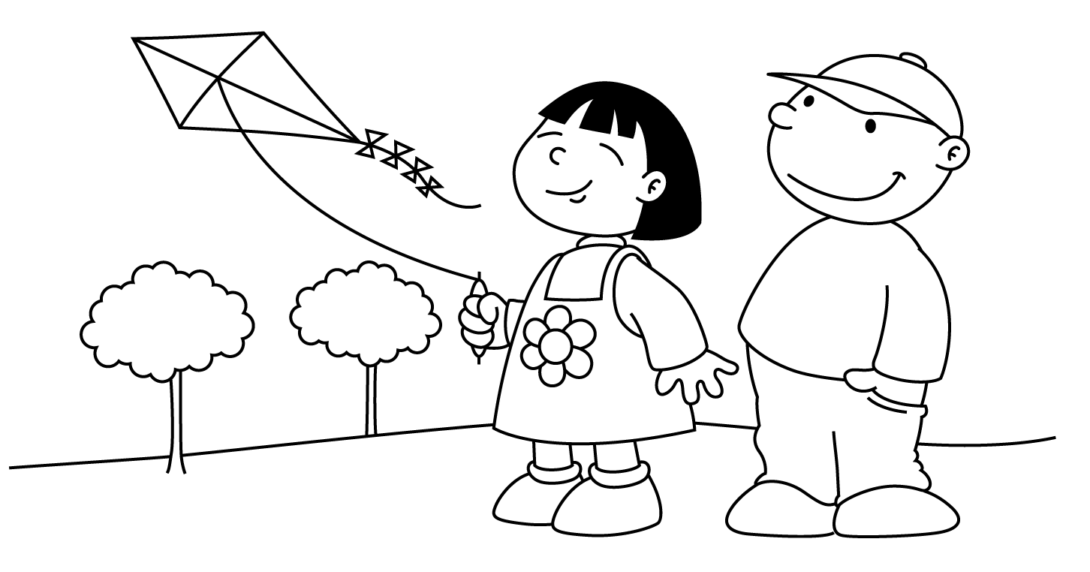

MARCH
Sunday | Monday | Tuesday | Wednesday | Thursday | Friday | Saturday
Opposites | Up / Down | In / Out | 1  Before / After | 2  In Front /  Behind  Dr. Suess’ Birthday  Read Across America Day | 3  Science  Project  Melting Sensation |  | 4
5  Dr. Suess Week  Rhyming | Dd 6  Cat  In the  Hat | Dd 7  Thing 1  and  Thing 2 | 8  One Fish  Two Fish | 9  Green Eggs  and Ham | 10  Fox in Socks |  | 11
12  St. Patrick’s Day  Fun  Daylight Savings Time  Set Clocks Ahead | 13  Pot O’ Gold | 14  Mosaic  Shamrock | 15  Lucky  the  Leprechaun | 16  Hat  Day | 17  Happy  St. Patrick’s Day  Wear Green  Visit from Lucky |  | 18
19  Spring  Wind / Air | 20  First Day  of  Spring  First Day of Spring | Uu 21  Umbrella | Uu 22  Up, Up  Away  Wind/Air | Rr 23  Rain | Rr 24  Rainbow |  | 25
26  Nursery  Rhymes | Nn 27  Jack  Be  Nimble | Nn 28  Show  -n-  Tell | 29  Mary  Had A  Little Lamb | 30  Hickory  Dickory  Dock | 31  Humpty Dumpty

